

2024-2025
STANDARDS AND QUALITY REPORT AITHISG INBHEAN IS CÀILEACHD

Kilmuir Primary School – Bun-sgoil Chille Mhoire

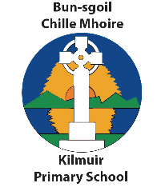
Introduction: Local and National Context
Ro-ràdh: Co-theacsa Ionadail agus Nàiseanta

This Standards and Quality Report is influenced by both Highland and national priorities. These can be summarised as follows:

Highland Priorities  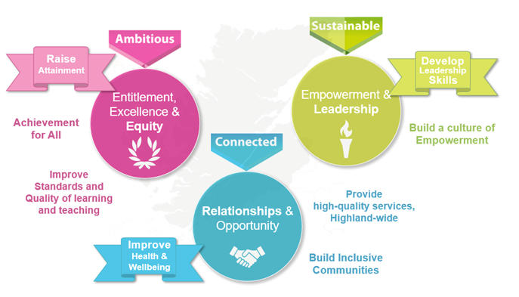  Entitlement, Excellence & Equity:  We will raise attainment and achievement for all, especially for children and young people from disadvantaged circumstances, including rural deprivation. We will focus relentlessly on improving standards and the quality of learning and teaching, to ensure that entitlement, equity and excellence are delivered across the system.  Empowerment & Leadership:  We will develop leadership skills at all levels of the system, for now and the future, building a culture of empowerment and professional capital.  Relationships:  We will maximise health and wellbeing for all children and young people, to give them the best possible start in life. We will ensure every child and young person feels part of the community they live in.  Opportunity:  We will maximise opportunities for our children and young people, and for the wider Highland community and its visitors, through the provision of high-quality services. | National Improvement Framework Priorities  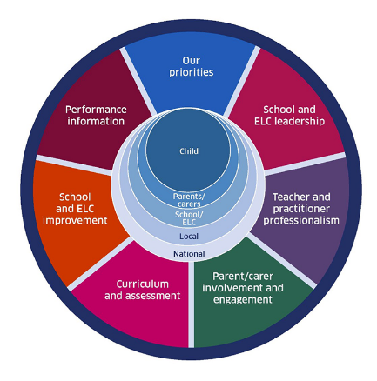  The key priorities outlined in the National Improvement Framework are:  - Placing the human rights and needs of every child and young person at the centre of education  - Improvement in children and young people's health and wellbeing  - Closing the attainment gap between the most and least disadvantaged children and young people  - Improvement in skills and sustained, positive school-leaver destinations for all young people  - Improvement in attainment, particularly in literacy and numeracy.  Self-evaluation  To support self-evaluation, quality indicators from the national evaluative framework How Good Is Our School?4 are referenced.  Links to these sources (and others referenced) can be found here:  National Improvement Framework Improvement Plan  HGIOS? 4 and HGIOELC  Health and Social Care Standards  National Gaelic Language Plan
In this report the following words are used to describe the numbers and proportions used:

All | Almost all | Most | Majority | Less than half | Few
100% | Over 91% | 75% - 90% | 50% - 74% | 15% - 49% | Up to 15%

We are pleased to present our Standards and Quality Report for Session 2024-25. This report provides important information regarding our school’s progress to date and our next steps in school improvement.

Self-evaluation for self-improvement is at the heart of what we do. We continue to develop our practice in making robust use of evidence as a basis for judgements regarding the impact of our work on our learners. All staff understand that self-evaluation is an integral aspect of our approach to continuous improvement through addressing the 3 key questions:

- How well are we doing?
- How do we know?
- What are we going to do now?

Throughout the year we continuously evaluate what we do and how it makes a difference to our learners. We want to know what is working well for our school community and what needs further improvement. We inform decision making and actions through a continuous process of looking inwards, outwards and forwards.

Looking inwards - starts with those working with our children and young people
We focus on the impact on outcomes for learners. Our self-evaluation processes triangulate information, data, people’s views and observation of practice to measure impact and inform planning for improvement.

Looking outwards - learning from others
Looking to others for new ideas that challenge our practice and support continuous improvement allows us to learn from what works and what doesn’t. This includes practice in other schools, learning communities and learning from educational research.

Looking forwards - creating a vision and planning for implementation
Through leadership at all levels, we anticipate challenges and explore creative solutions. This helps us to create an aspirational vision for our school which shapes our actions and provides a focus for improvement.
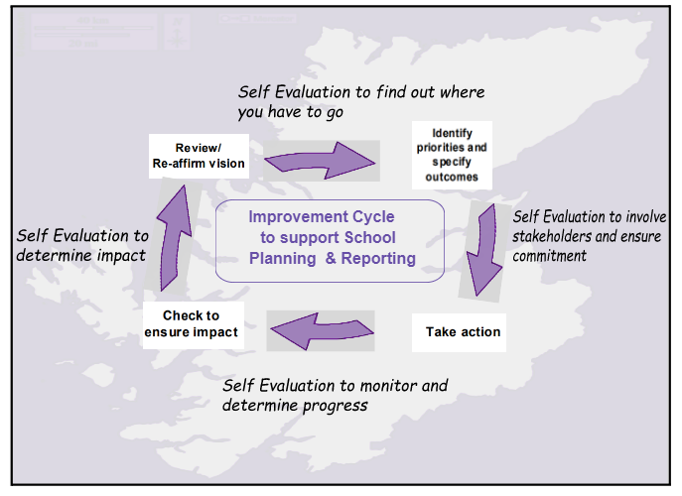
Our children and young people are actively consulted and involved in this process. We also give staff, parents/carers, and other partners the opportunity to participate in discussions and activities to shape our improvement journey.

When we develop our improvement plan, we use key questions at scheduled review times throughout the session to know how well we are progressing towards achieving these positive outcomes and changes.

Together we are working hard to ensure the Highlands is the best place for children and young people to grow up safely, learn, develop and achieve.

With positive experiences, our children and young people will always see the Highlands as home.
Le eòlasan deimhinneach, bidh ar cloinn is ar n-òigridh daonnan a’ faicinn na Gàidhealtachd mar dhachaigh.

Name
Head Teacher
School

School Profile
Pròifil na Sgoile

The following information can be found on Parentzone Scotland. It is important to remember that statistical data alone is not a measure of how well we are doing. All schools are unique. To understand how well we are doing it is important for us to look at a range of different data sources.
Delete yellow instructions and what is not relevant to your context

All primary schools to include
Attendance  94.1% |  | Average Class Size  8 |  | Meeting PE Target  Target Met
Pupil Numbers (inc nursery)  5 |  | Teacher Numbers  4 |  | Pupil Teacher Ratio  4.3

2024/25 Proportions of pupils achieving Curriculum for Excellence Levels (P1, P4, P7 combined):
Reading |  | Writing |  | Listening and talking |  | Numeracy
All |  | All |  | All |  | All

Gaelic Medium 2024/25 Proportions of pupils achieving Curriculum for Excellence Levels (C1, P4, P7 combined):
Gaelic reading |  | Gaelic writing |  | Gaelic listening and talking
All |  | All |  | All

We have had no exclusions this year.

Kilmuir Primary School is located in a small, rural school serving the local communities of Kilmuir & Uig on the Isle of Skye.

There are 14 children attending the school and 6 children in nursery, ranging from N3 - P7. In both English and Gaelic Medium, P1 – 7 are taught together multi-stage classes and there is a separate nursery for 3 and 4 year olds.

The headteacher has overall leadership responsibility for Kilmuir Primary School and Sgoil Stafainn. Staff and children from both schools work together regularly.

As the school roll comprises a small number of children, attainment and progress will be expressed in ‘overall’ statements, rather than specific year groups or Curriculum for Excellence levels. This is to ensure the identity of individuals is not disclosed.

Overall, attainment across the school in literacy and English and numeracy and mathematics is very good. Children achieve appropriate CfE levels in literacy and numeracy and, across the school, the majority of children are exceeding nationally expected levels. Most children who face barriers to learning are making good progress towards meeting their individual targets.

Overall children are making the following progress:
Reading |  | Writing |  | Listening and talking |  | Numeracy
Good progress |  | Good progress |  | Good progress |  | Good progress

Gaelic Medium (delete if not relevant):
Gaelic reading |  | Gaelic writing |  | Gaelic listening and talking
Good progress |  | Good progress |  | Very good progress

School vision, values and aims
Lèirsinn, luachan agus amasan na sgoile

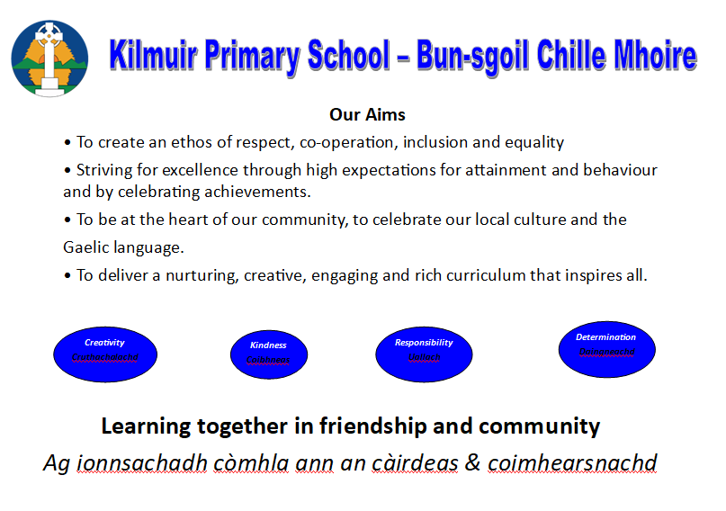

Review of progress for session
Ath-sgrùdadh air adhartas airson an t-seisein

These projects are linked to the vision and priorities for Scottish Education based on delivering excellence and equity. Parent/Carer information is available here.

School Priority:
Improving Numeracy
Purpose:
This project has been developed in response to dips in attainment in Numeracy across Highland.

Progress:  - We have continued to raise attainment in numeracy in line with stretch aims.  - Professional learning - All practitioners (including EYPs) engaged in professional learning with the Numeracy Support Officer.  - The sgoil-àraich and the school work together to plan interesting numeracy activities for children.  - All teachers engaged in professional learning around using data to inform planning.  - Number Sprinkles Planner in use across the school.  - The gap between the most and least disadvantaged children and young people has closed, in line with The highland Council stretch aims. | Impact:  - We have seen an increase in pupil attainment in numeracy. This is evident in Highland Numeracy diagnostic assessments, SOFA, SNSA and MCNG assessment results. A few children have gone from Below Average to Above Average results.  - Teachers and EYPs have a greater knowledge and confidence in planning numeracy activities, supported by the use of the authority resources.  - Pupil Focus groups, Lesson observations and sgoil-àraich engagement observations have shown that active learning strategies are in use in all classes.  - Teachers are using assessment results to track progress and plan interventions, supported by PSAs. These are recorded in ‘Big Questions’ after Termly attainment meetings between the HT and Class Teacher.  - Teachers are using the number sprinkles approach, which is helping to improve pupil confidence. Almost all pupils said they were supported and challenged in class.  - Through the use of interventions such as the 5 minute numeracy box and precision teaching materials, we have seen the gap close between the most and least disadvantaged children. This is tracked in P&A and in our school tracker.  - Satisfactory progress was made in this area.
Next steps:
- We will continue to work with the Highland Council Numeracy Officer to support attainment and to ensure consistency across the schools next year.
- Teachers, PSAs and EYPs across the cluster will continue to work together to ensure results from assessments directly inform planning and support pupils.
- We will continue to look at ways to support learners including using Nessy for maths and purchasing support trolleys.
- To continue to build time into our WTA for staff training, so that all staff are aware of the new Highland Council strategies and materials on SharePoint and google drives.

School Priority:
Improve approaches to Learning & Teaching
Purpose:
Ensure consistency of learning & teaching, based upon Bruce Robertson’s 12 key elements, in The Teaching Delusion.

Progress:  - Staff have continued to take positive steps in improving learning, teaching and assessment approaches across the school.  - We have completed our Teaching sprints based on Bruce Robertson’s ‘Power up your Pedagogy’ and reflected on lessons using our ‘lesson evaluation toolkit.’ The Northern Alliance toolkit and Continuing Professional Development sessions have supported Pedagogy across the Cluster.  - Staff interrogated data to support and challenge pupils. We have used PSAs to lead interventions. We have used our assessment and parental engagement calendar to drive improvement.  - Practitioners continue to use total immersion approaches effectively in sgoil-àraich. These include commentary, songs and role-play.  - Practitioners in sgoil-àraich are using stories and tuff trays to support language acquisition. | Impact:  - Almost all children experience high-quality learning across the curriculum, as observed by HT and CLO in lesson observations.  - The 12 key elements of lessons are evident across the school. Pupils are able to talk about their learning and most pupils can discuss careers and meta-skills. Teachers have appreciated being able to look at specific aspects of learning and teaching and link them to reading.  - Interventions are happening daily and are scheduled. We are identifying trends and planning interventions to support pupils.  - Children are curious, independent and confident while learning through total immersion play. They benefit from a bright, nurturing environment and caring EYPs.  - EYPs use children’s ideas to plan a range of interesting and stimulating experiences. Parental comments show that children and parents are happy in sgoil-àraich.  - Satisfactory progress was made in this area.
Next steps:

- Staff will continue to commit to regular CPD sessions based on Learning & Teaching.
- Next year we will include a literacy focus in our SIP.
- Staff across the cluster will continue to work and plan learning together.
- We will build in more opportunities for the ASG to work together.

School Priority:
Assessment and Moderation – Moderation Collaborative
Purpose:
To develope consistency across the cluster.

Progress:  - Data shows that all staff are using the tools to support moderation and inform learning and teaching.  - All staff will have analysed NSA and SOFA data and have planned interventions for those children not on track.  - School tracking data will indicate increasingly accurate judgements in overall Literacy and Numeracy across the schools involved.  - Almost all staff report improvement in teacher confidence in making ACEL judgements.  - In sgoil-àraich, staff are discussing Developmental Overviews regularly and supporting children to achieve their full potential. | Impact:  - Staff have used a range of tools and trackers to support moderation. Staff have attended moderation training and have also joined the HC Gaelic Moderation group.  - All staff have reflected on results and interventions are well planned.  - Our judgements are more robust by using tools such as the end of year target sheets. Tracking is discussed in attainment meetings and achievement of a level evidence is reviewed.  - Staff are gaining confidence in make ACEL judgements, as seen in staff survey results.  - Sgoil-àraich staff are supporting individual needs and tracking learning with high quality observations and in developmental overviews. Staff are also tracking language acquisition.  - Good progress was made in this area.
Next steps:
- Continue to use Highland Council tools to support moderation, such as the End of Year Targets, Literacy Roadmap and Learning conversations sheets.
- Build in ASG moderation into our assessment calendar.
- Develop our school tracking to include spelling
- Sgoil-àraich staff will visit other settings to moderate learning journals

Progress and impact of Pupil Equity Fund
Adhartas agus buaidh Maoin Cothromas Sgoilearan

- We used PEF funding to support pupils to attend swimming lessons and cover transport costs involved in attending high quality ASG PE events. Pupils’ wellbeing have benefited from attending these events and our P7 pupils well supported in their transition to High School, due to these events.
- 100% of the target group are now on track in numeracy. 100% of pupils had increased 1 band in numeracy from November to May. 1 pupil had increased 2 bands.
- 100% of the target group are now on track in literacy. 100% increased 1 band in numeracy from November to May.

Wider achievements
Coileanaidhean nas fharsainge

- Our pupils were very successful at the local mòd.
- This year we have entries for the National Mòd
- All pupils did dance with Skye Dance.
- The Gaelic Medium pupils did a successful Gaelic enterprise project and attended a craft fayre in Kilmuir hall.
- All pupils have participated in Gaelic sining with Anne Martin and all received our new Gaelic Song Book. Most pupils participated in our Community Family Cèilidh.
- 1 x Pupils participate in string lessons, 2x pupils – chanter/piping lessons, 1 x pupil in drumming lessons.
- The Majority of our pupils attended Feis Throndairnis.
- All pupils attended swimming blocks in Portree
- Pupils attend out of school clubs – swimming/ active schools / guitar lessons
- All P5-7 pupils had sessions with Spòrs Gàidhlig.
- Partnership working with the Highland Council Gaelic Team for Gaelic Medium events.
- All pupils participated in our DYW week and experienced a range of careers in English and Gaelic.

Comments from learners, families, stakeholders and staff
Beachdan bho luchd-ionnsachaidh, teaghlaichean, luchd-ùidhe is luchd-obrach

Pupils
What works well in the school?
- Fun activities like painting, PE, outdoor learning and singing songs
- Resources – we all have ChromeBooks
- We all work together as a team
- We got swimming certificates
- Committees – we have our say in things
- Pupils are all friendly

What we could do better
- A better school trip
- Another opera trip
- New equipment in playground
- Better library with more books and seats
- Do more with Staffin

Partners
- It has been good to work with the school this year – what fantastic pupils!

Staff
- I think everything is working well, overall the school works well as a team, staff are well managed and are all good at communicating together. Definitely a great environment for children and staff to thrive.
- Pupils are nurtured and listened to and that every pupil is achieving/ making progress.
- Pupils have really enjoyed taking part in events this year - Anne's singing practices, DYW week.
- I feel the numeracy training from Emily has been helpful, with practical suggestions, and she has been helpful in supporting me with a pupil who is struggling.

Parents
What works well in the school?
- The kids get a lot of support and attention due to small class sizes. They all seem to get on with each other and play together well. They mostly seem to enjoy their time there.

What we could do better
- Dyslexia support

Capacity for continuous improvement
Comas airson leasachadh leantainneach

Using indicators from ‘How Good is our School 4’ together with learner, parent, carer, partner and community feedback we believe we have made the following progress this session:

 | ELC | PRIMARY
QI 1.3  Leadership of change | Good | Satisfactory
QI 2.3  Learning, teaching and assessment | Good | Satisfactory
QI 3.1  Wellbeing, equality and inclusion | Good | Satisfactory
QI 3.2  Raising attainment and achievement/Securing children’s progress | Good | Good

Our overall evaluation of our capacity for continuous improvement is:
We are confident in our capacity for continous improvement.

Key priorities for improvement planning
Prìomhachasan airson planadh airson leasachadh

- Continue to Raise Attainment
- Develop reading skills
- Develop Leadership Skills at all levels?

Planning ahead
A’ planadh air adhart

Full details of the school’s 2025/26 improvement priorities and actions are detailed on the school improvement plan, which can be accessed on our website www.kilmuirprimary.com or by contacting the school office.

